Assignment 3: Configuration Management Automation with Ansible

# **Pratham Sapra**

# **Student ID: 148047236 |** [**pssapra@myseneca.ca**](mailto:pssapra@myseneca.ca)

Project explanation video link: [Recording-20240309_211741](https://seneca-my.sharepoint.com/:v:/g/personal/pssapra_myseneca_ca/EWnEustBBjZAtyMchRu4iBgBI8KtLZxpmMnqee1vSKyYVw?e=77V5rE)

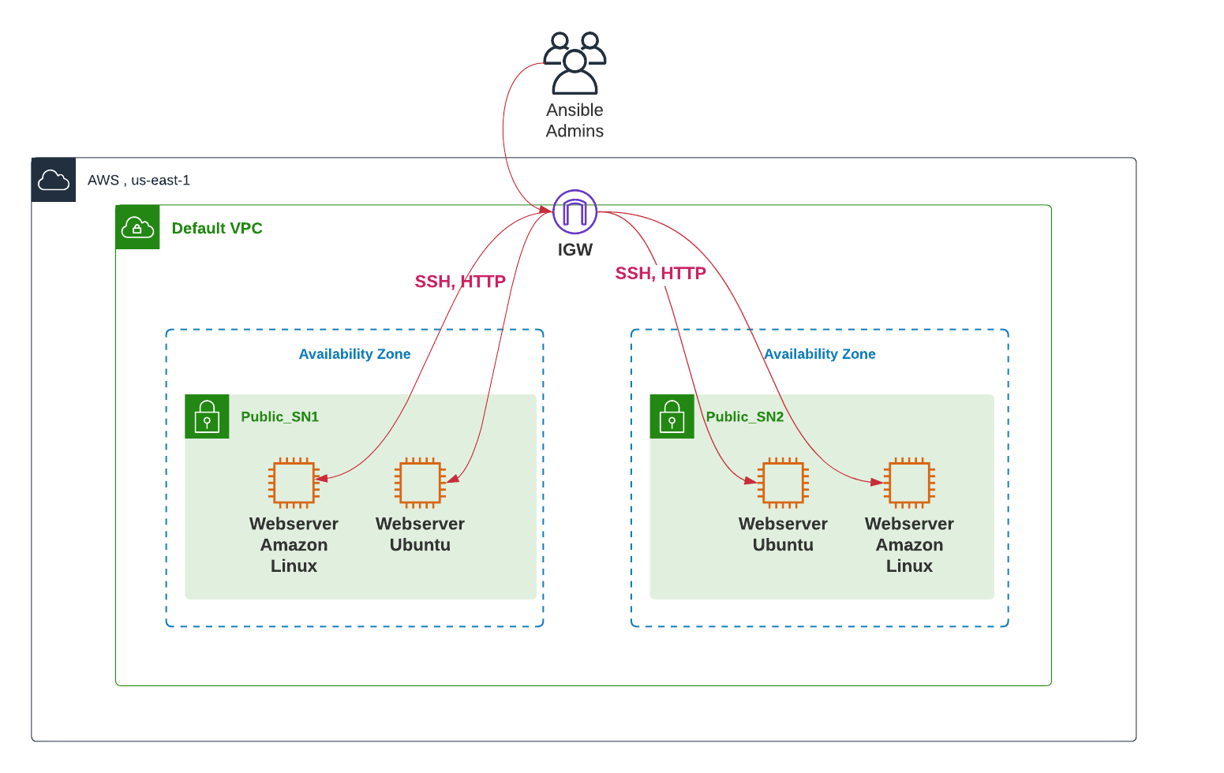

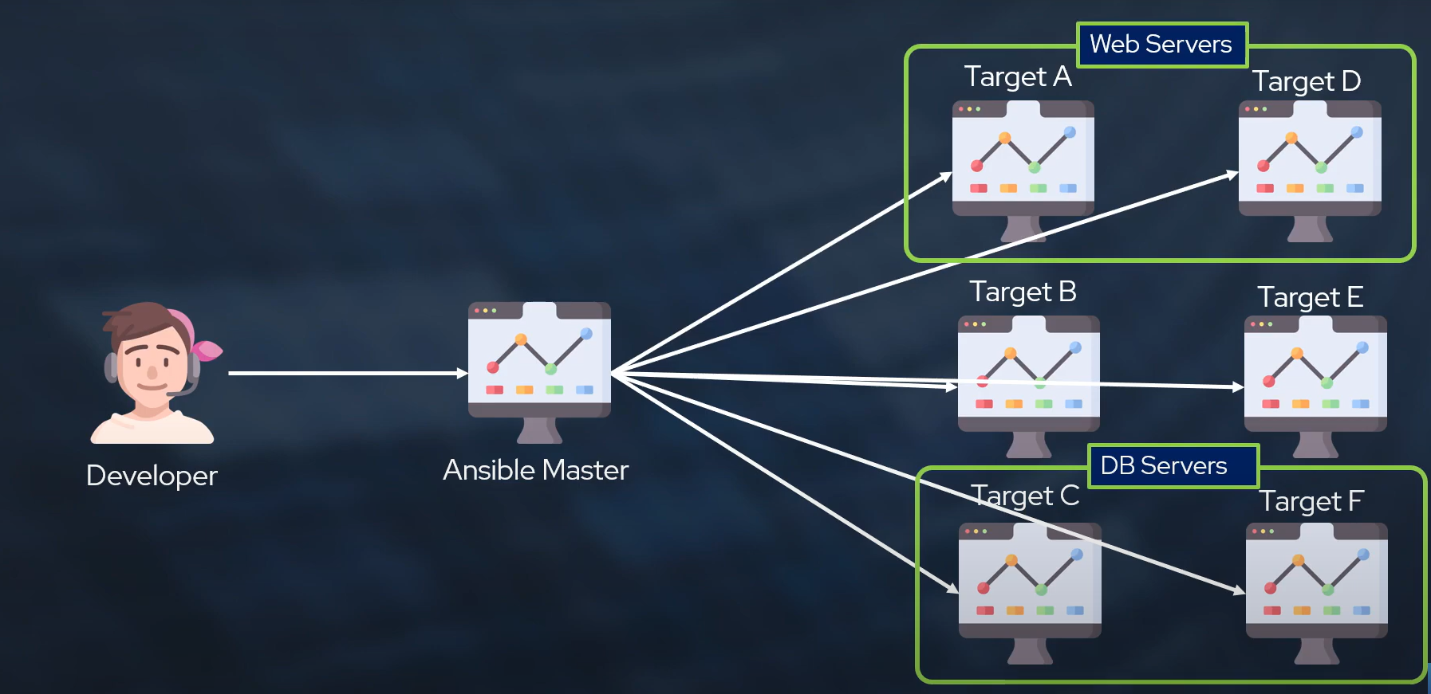

Admin Ansible

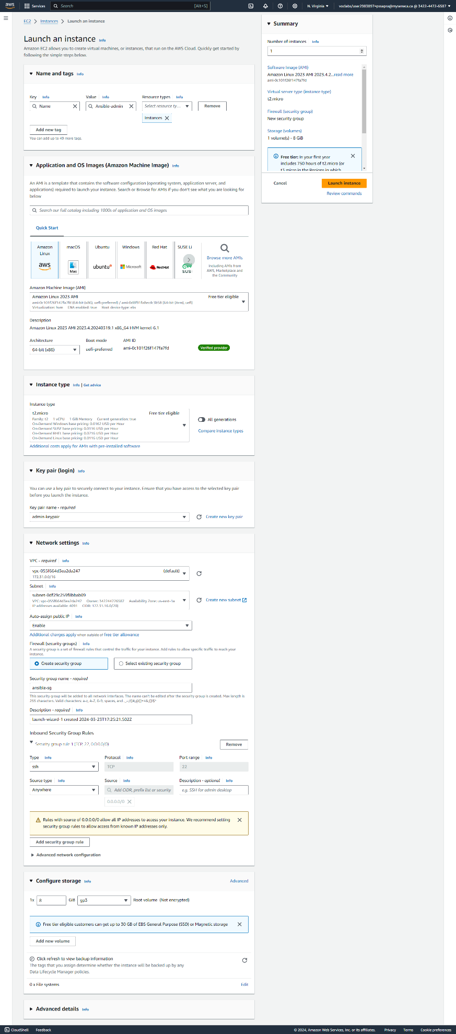

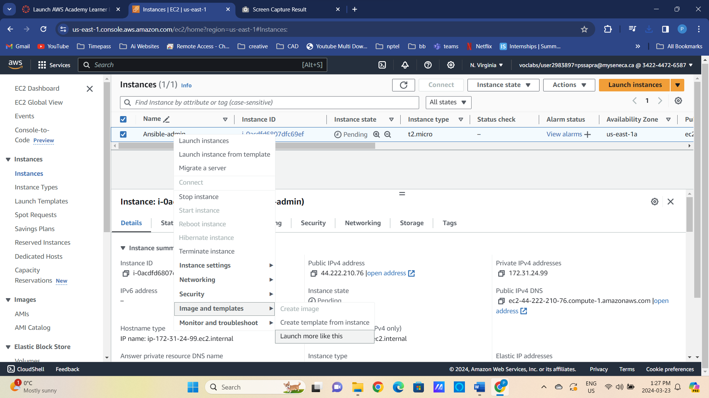

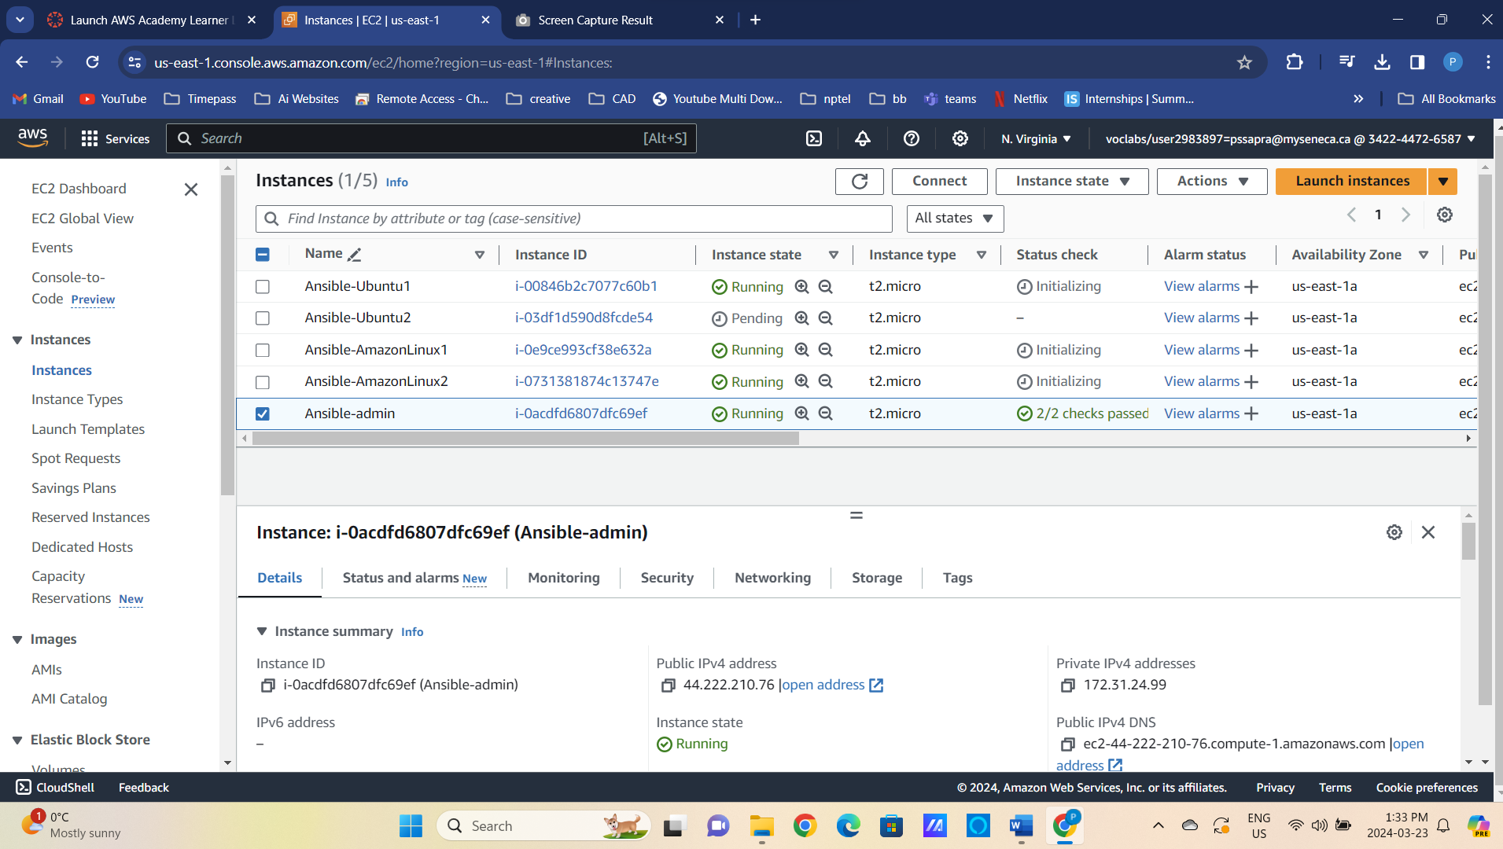

<https://termius.com/download/windows>

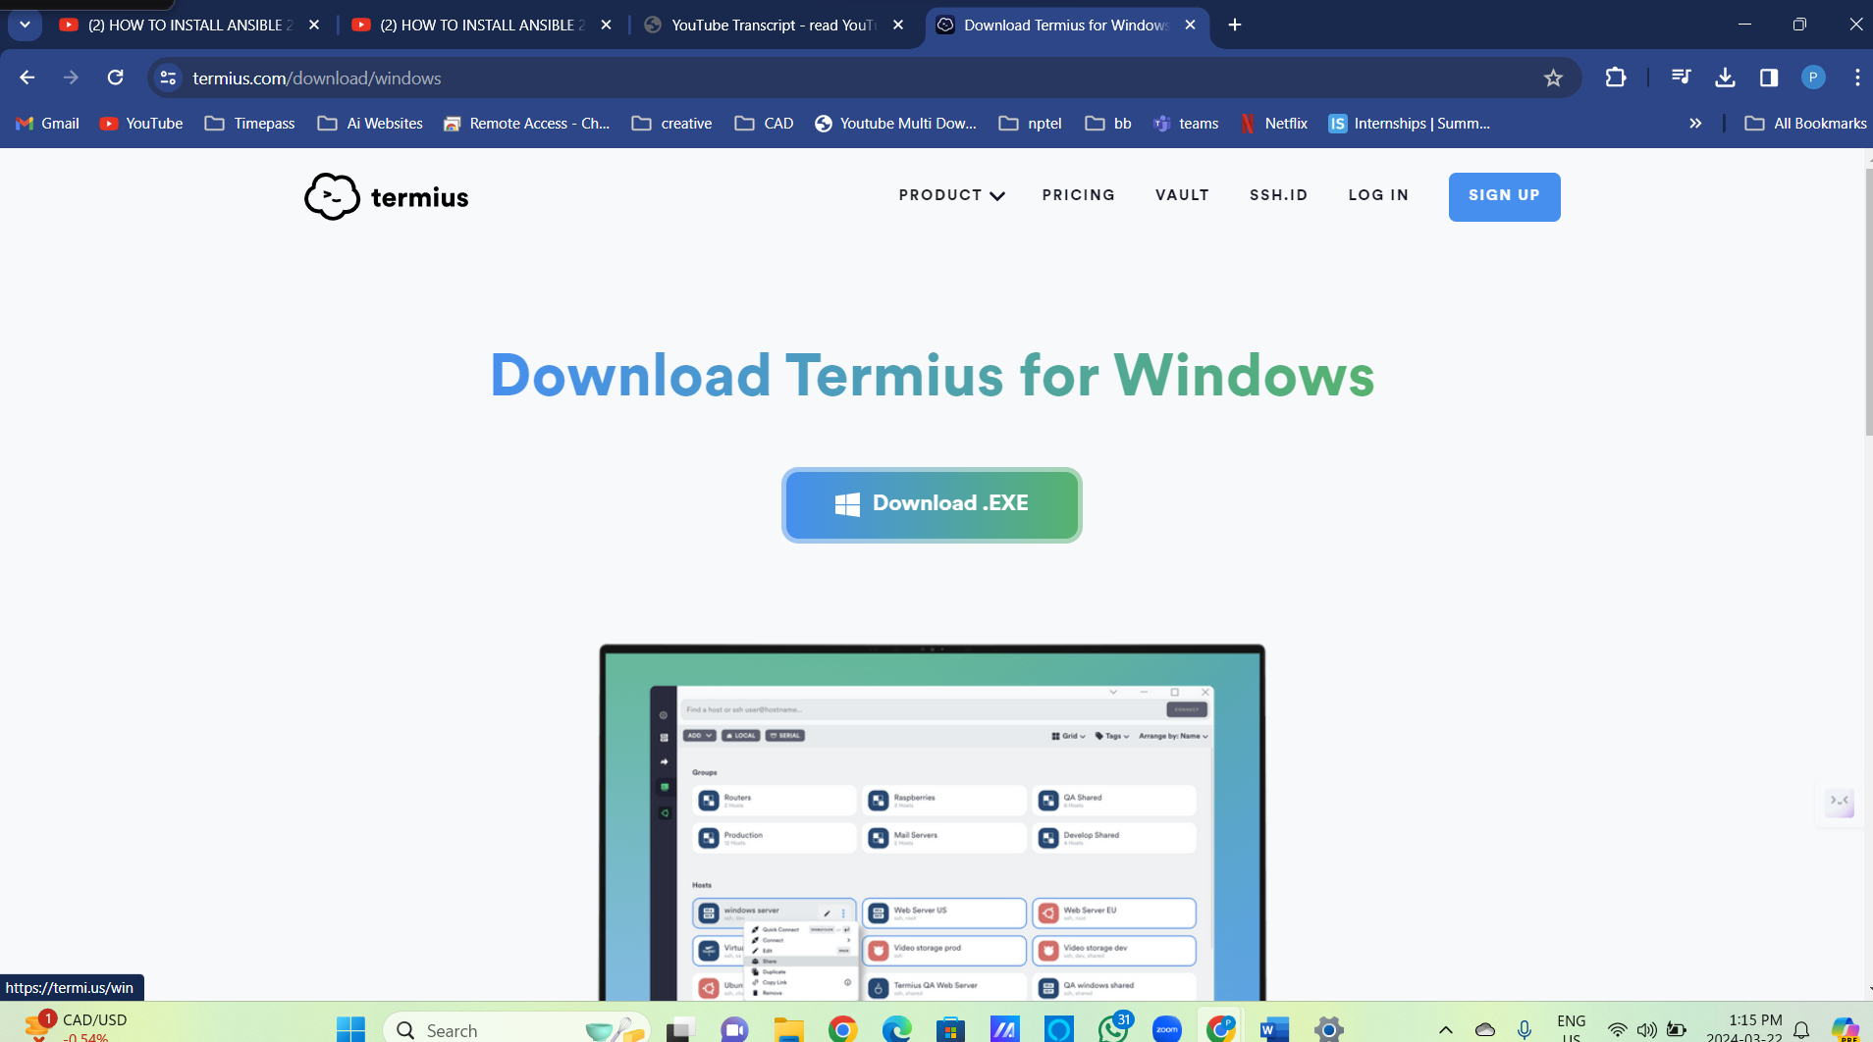

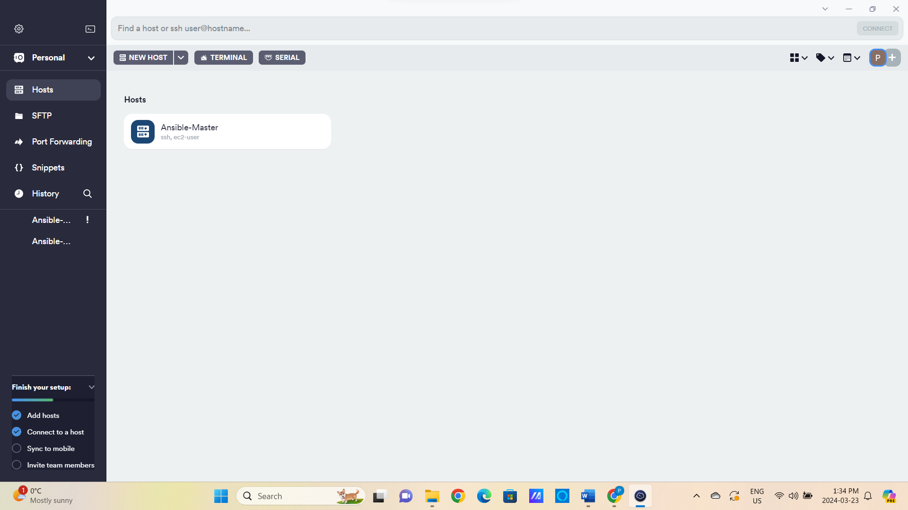

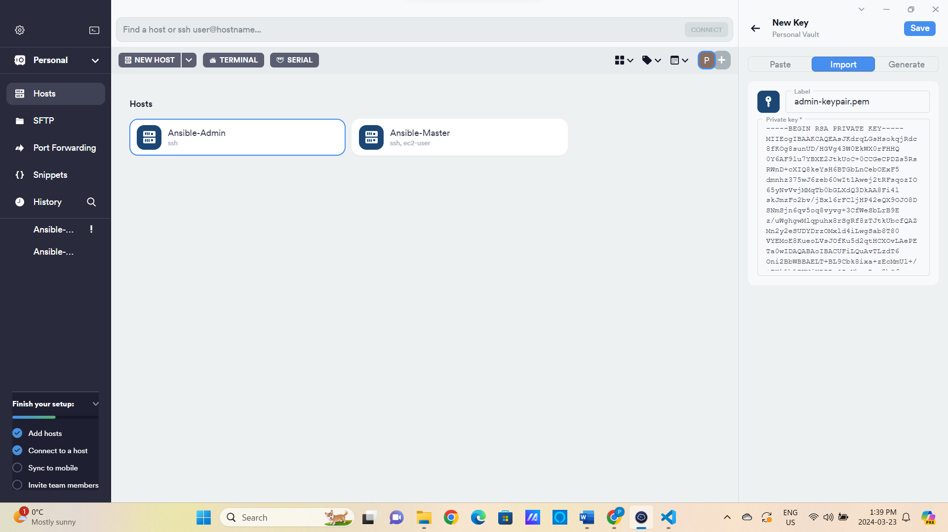

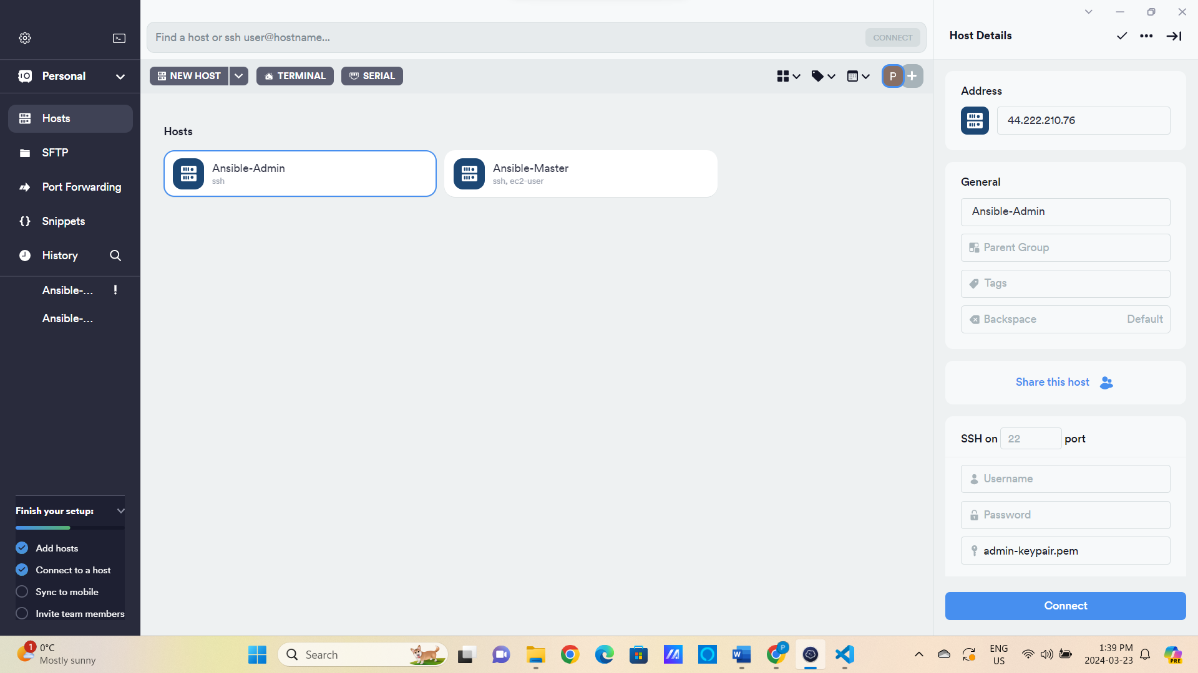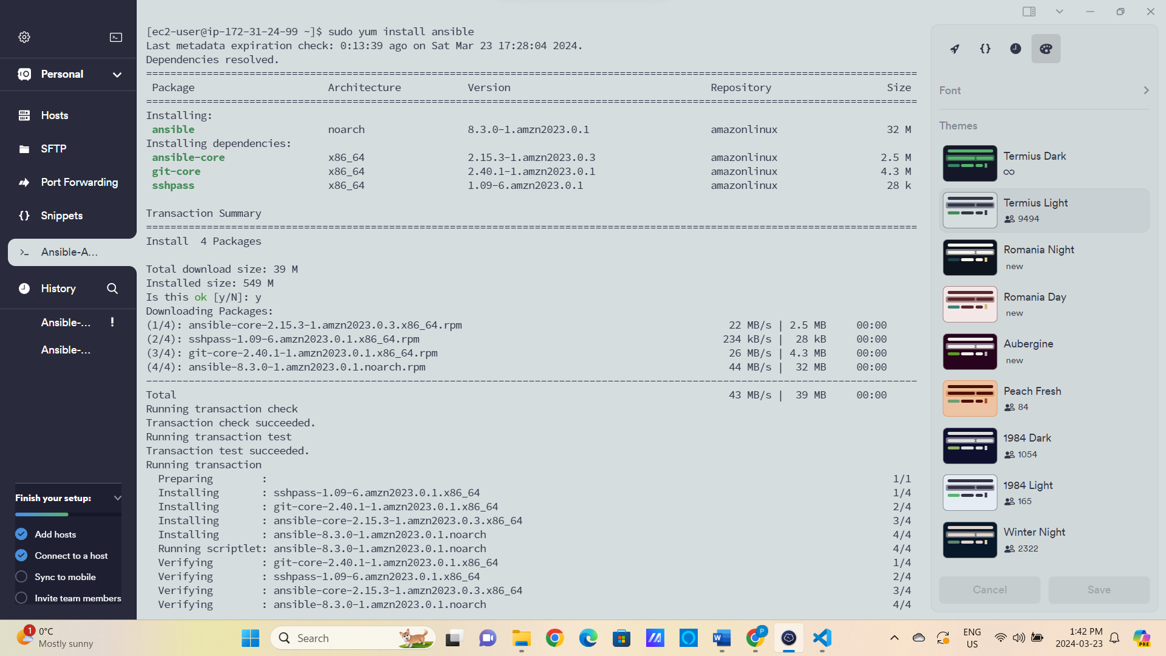

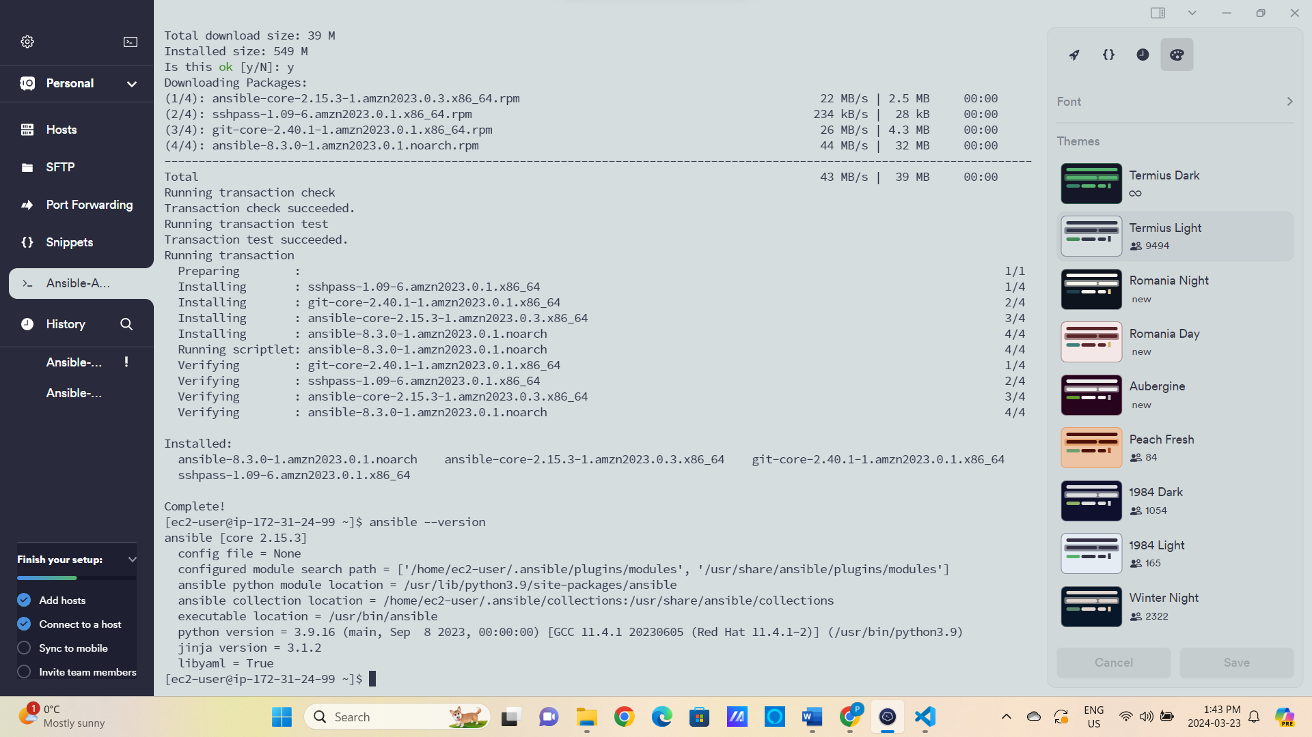

Ansible Installed Successfully

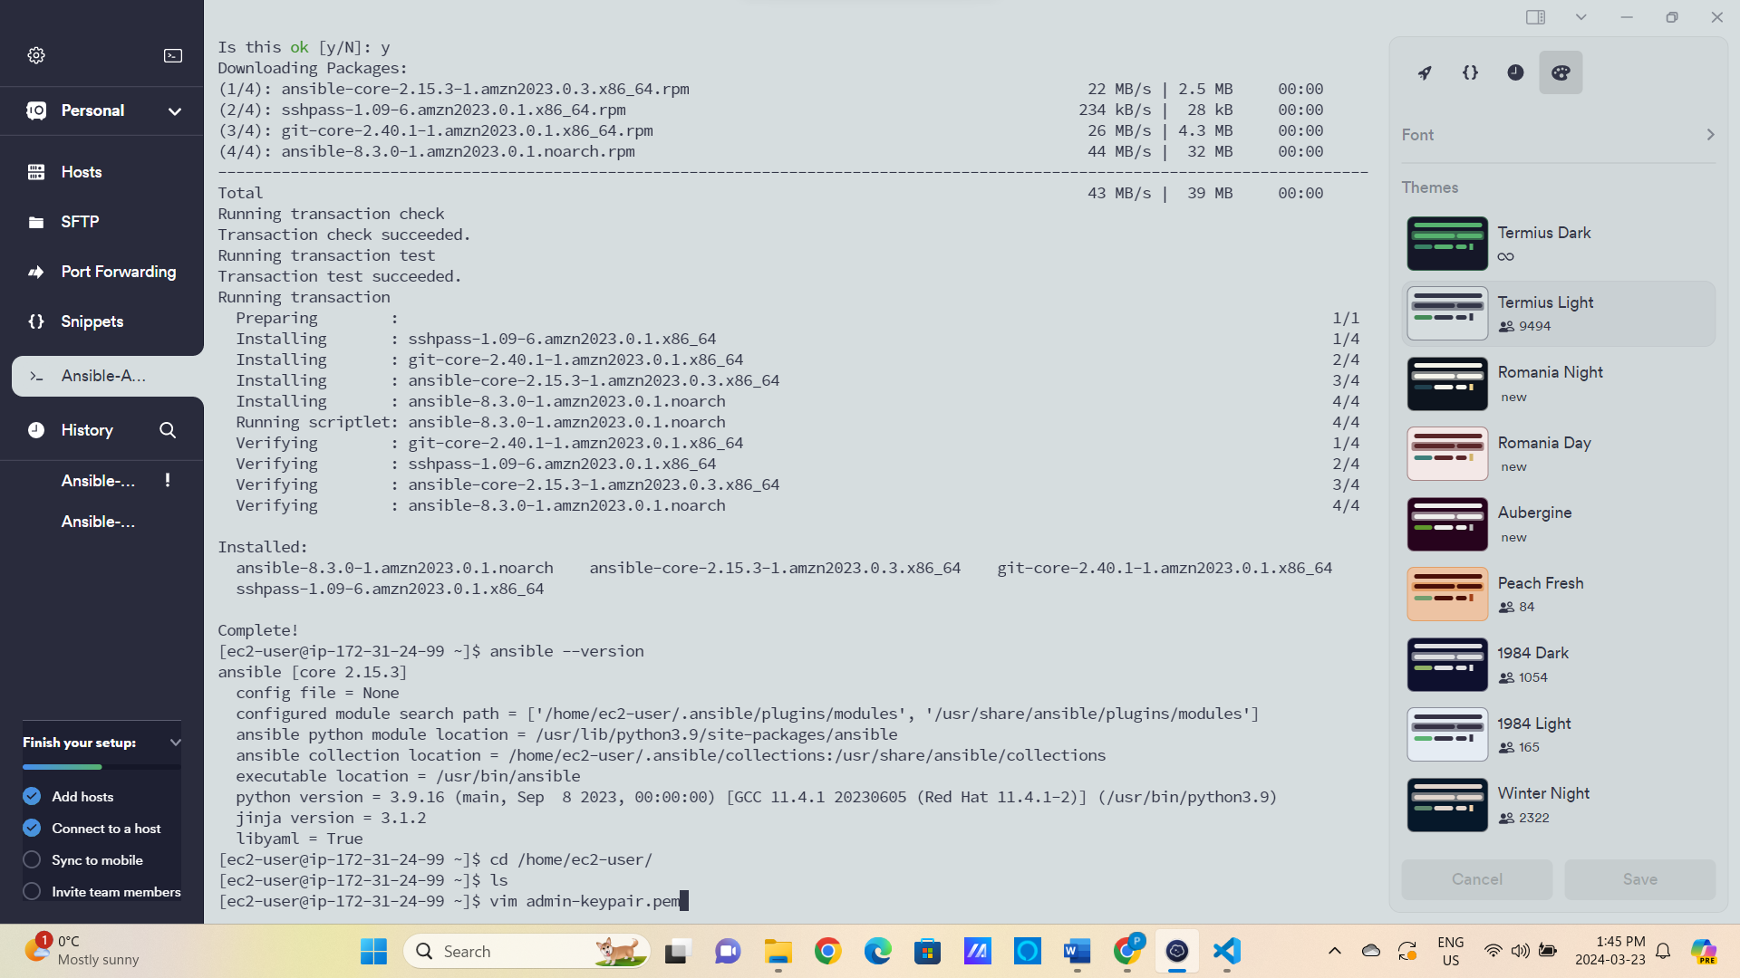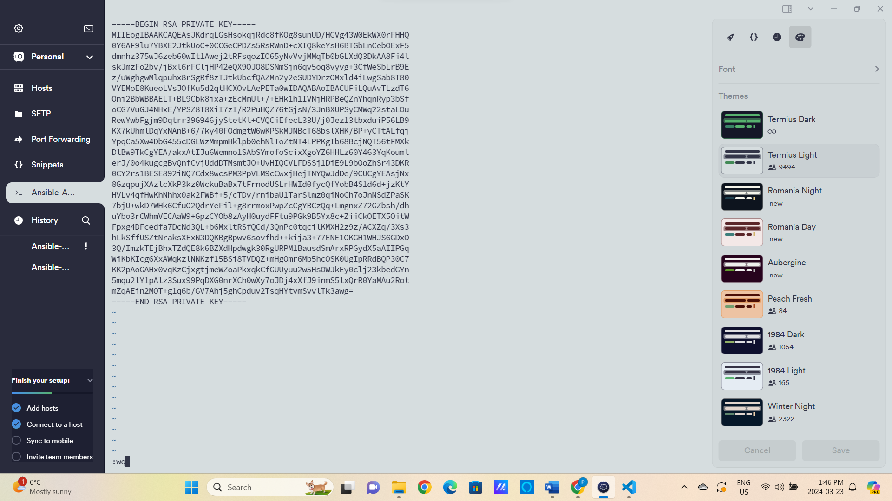

ctrl shift v



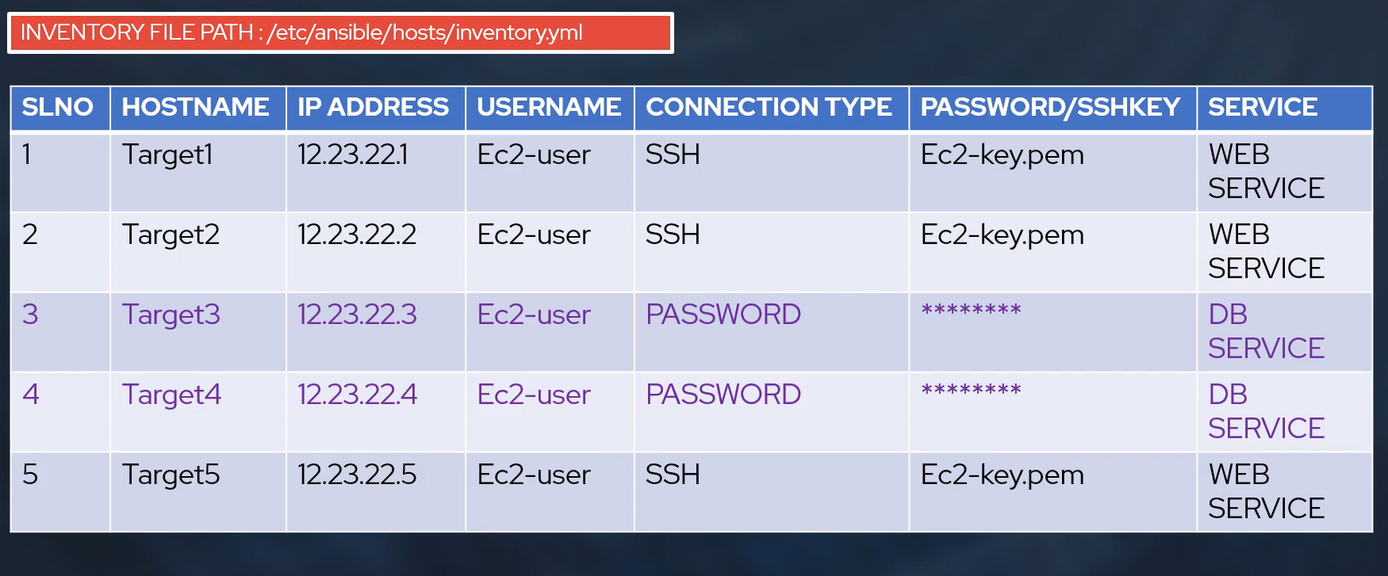

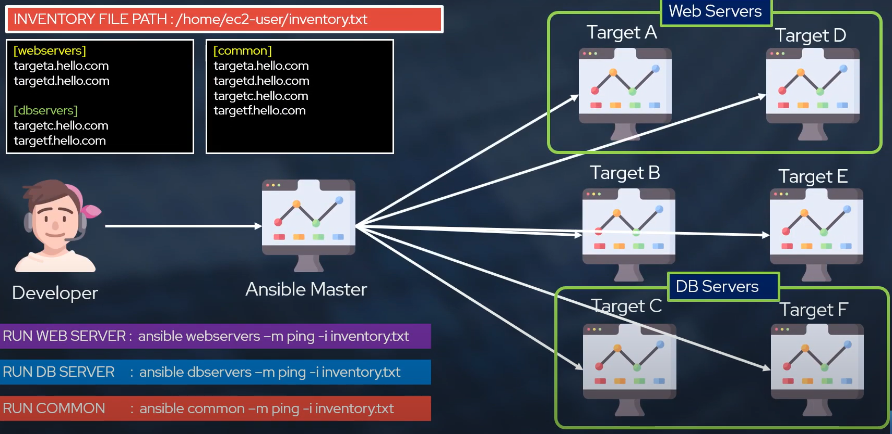

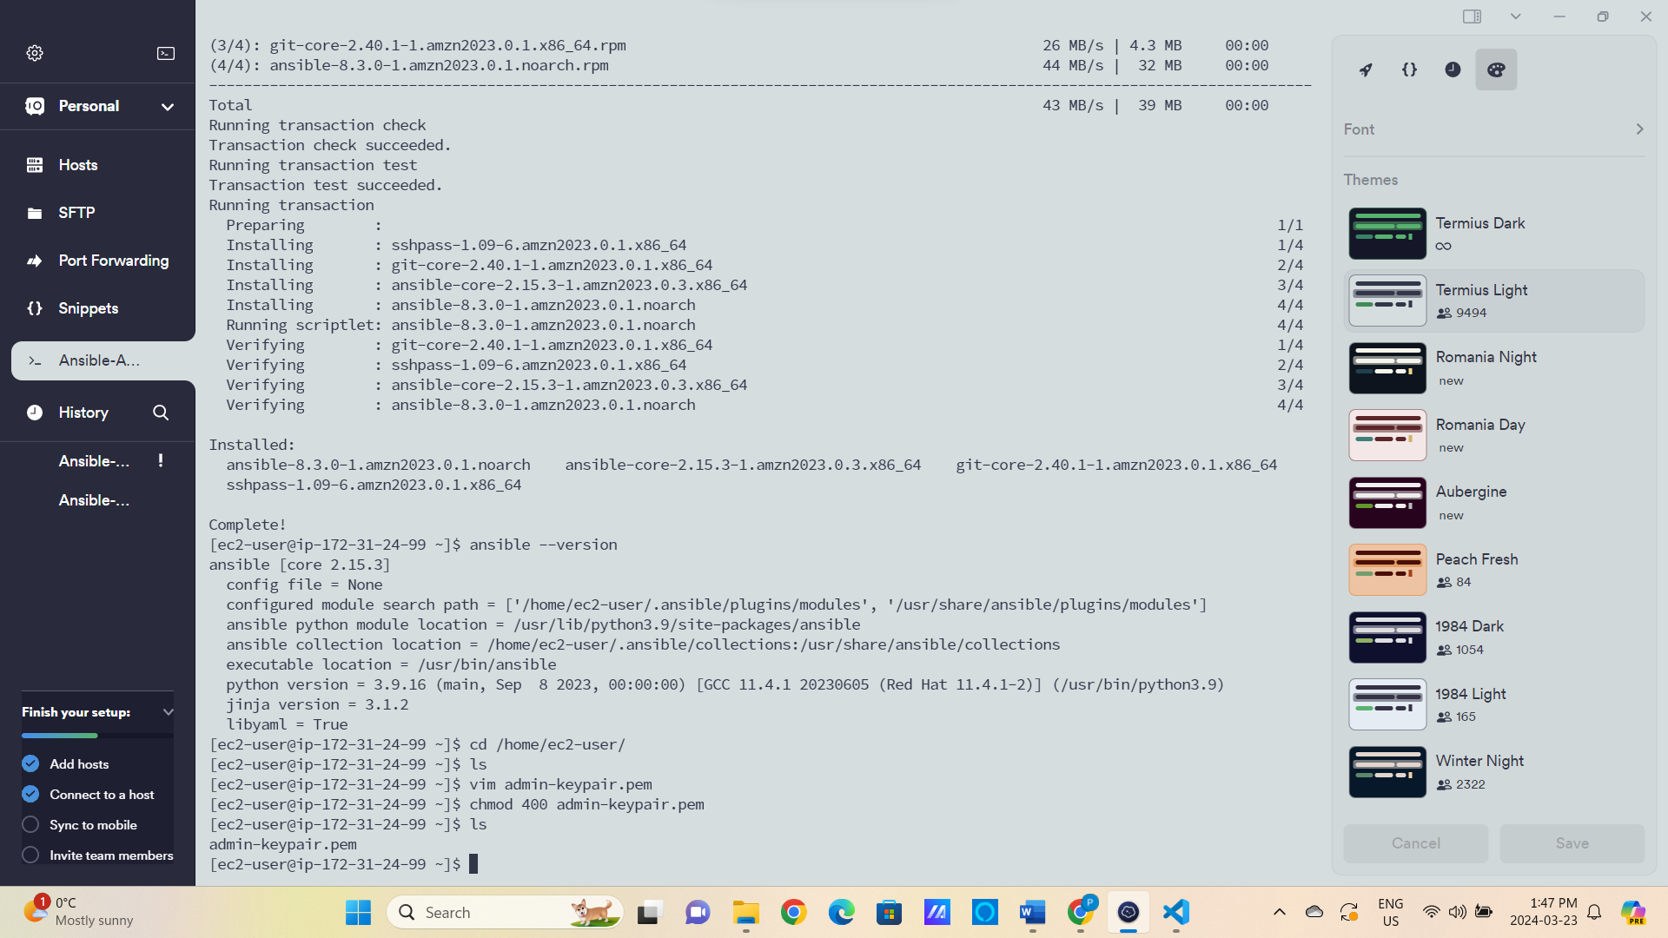

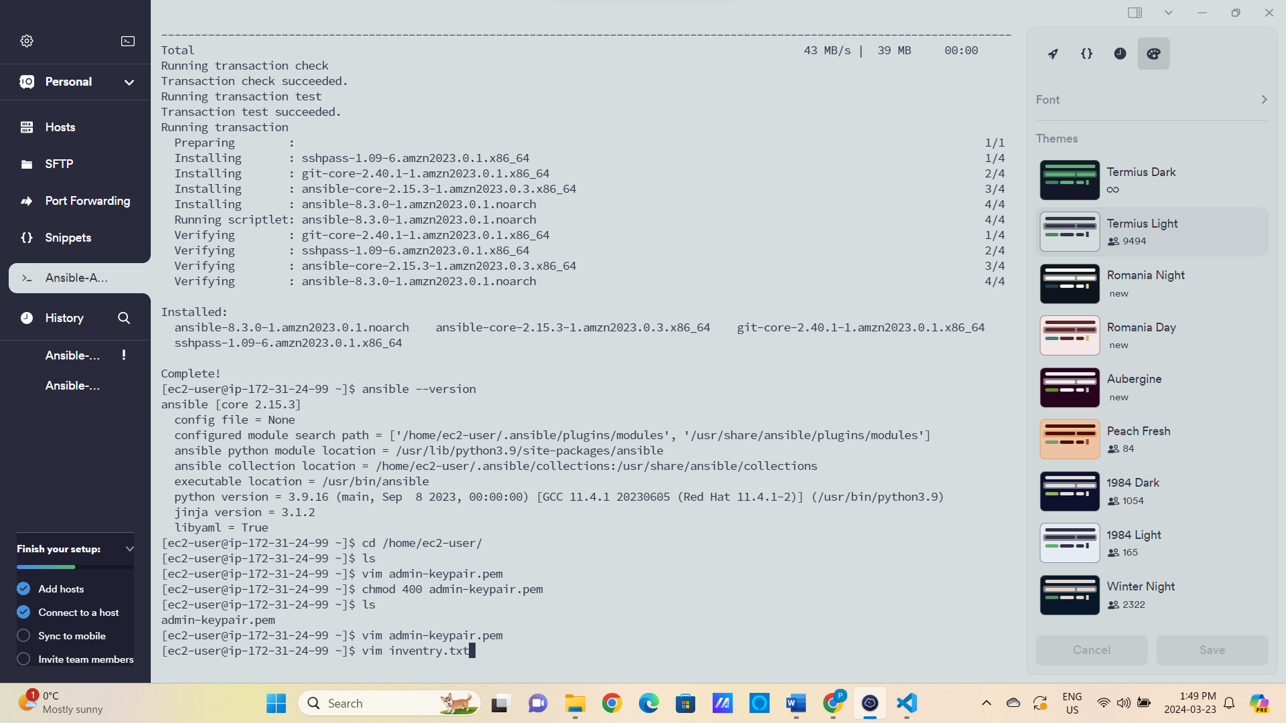

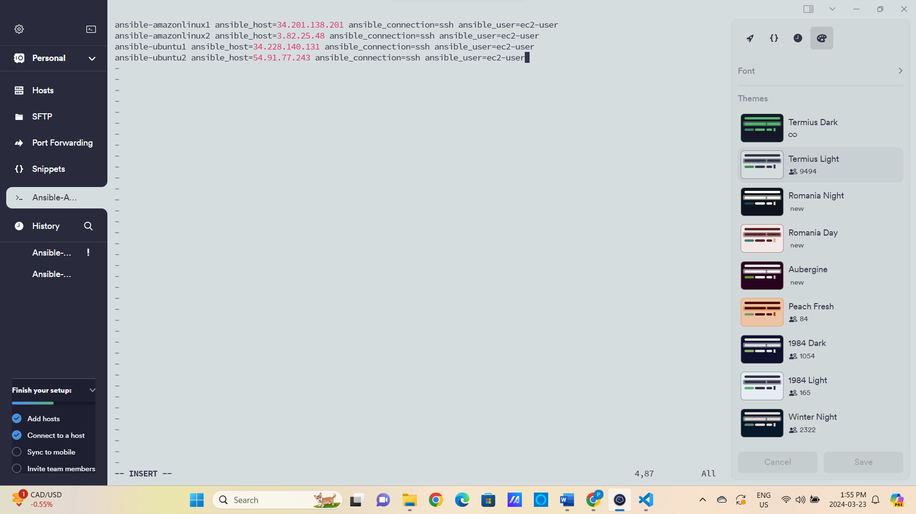

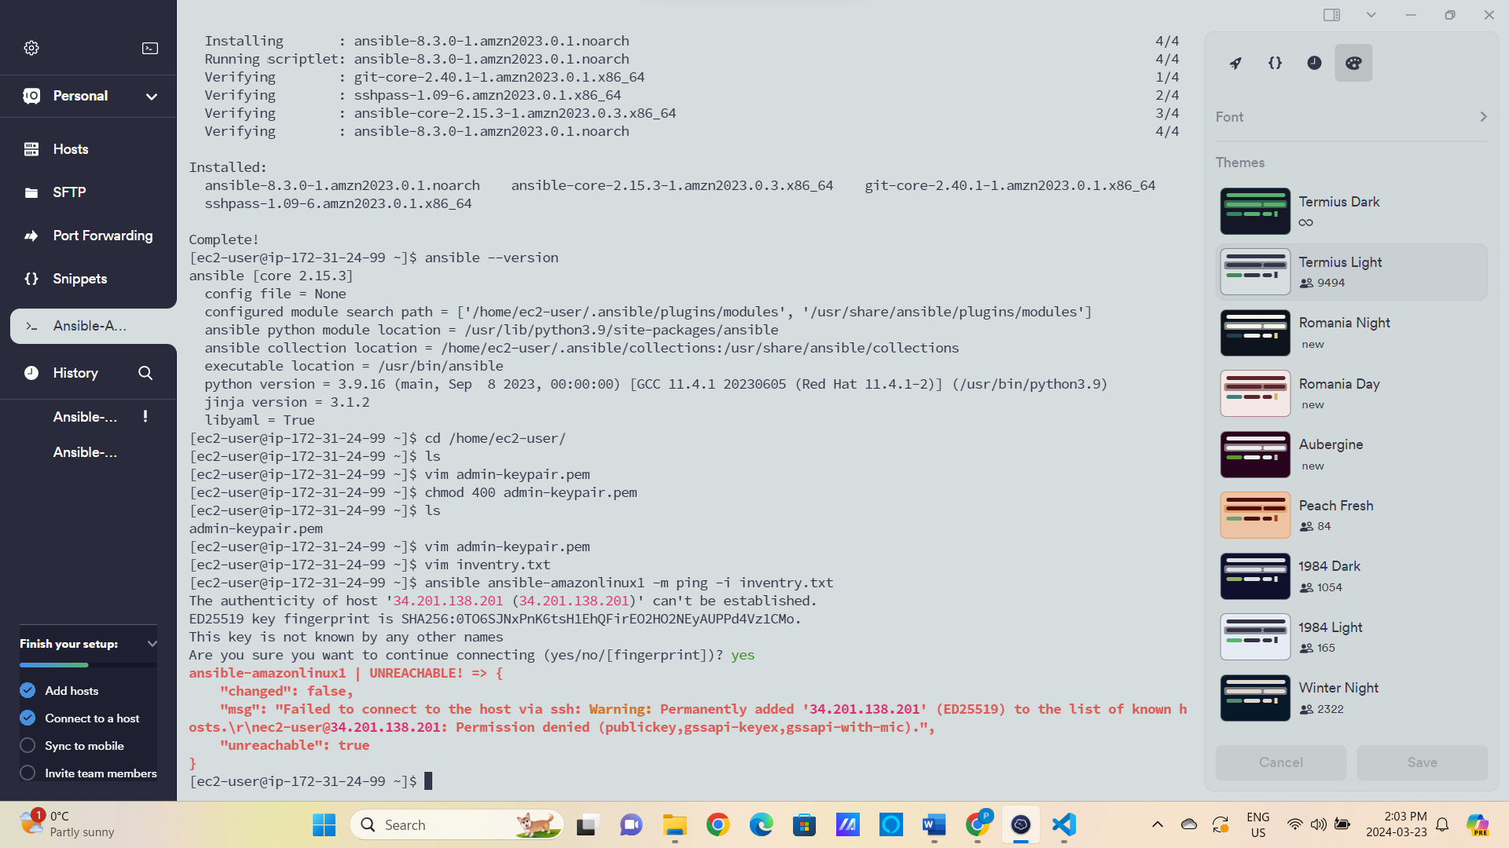

This will not work because only copying the key here is not sufficient.

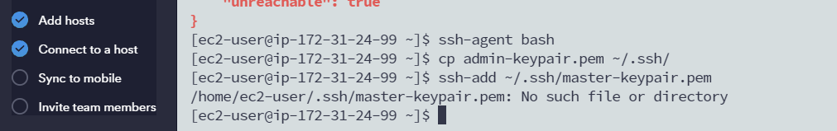



Now we will run the instance of AmazonLinux1

Here we see it always needs a manual intervention for every instance so to avoid that.



Now it is successfully connected without any manual permission

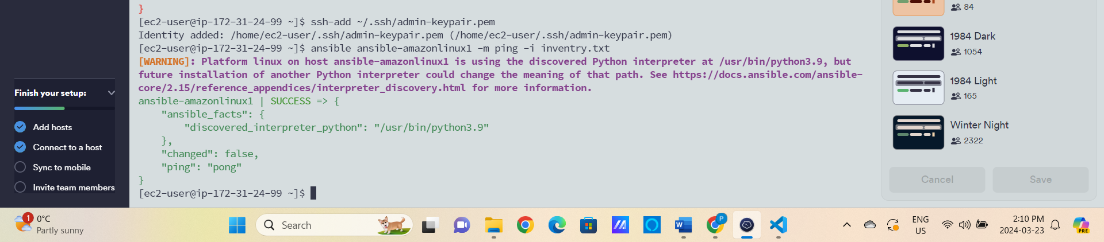

We added [servers] in the inventory file to connect to all at once

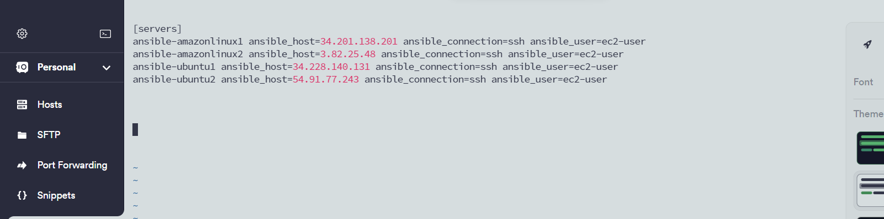

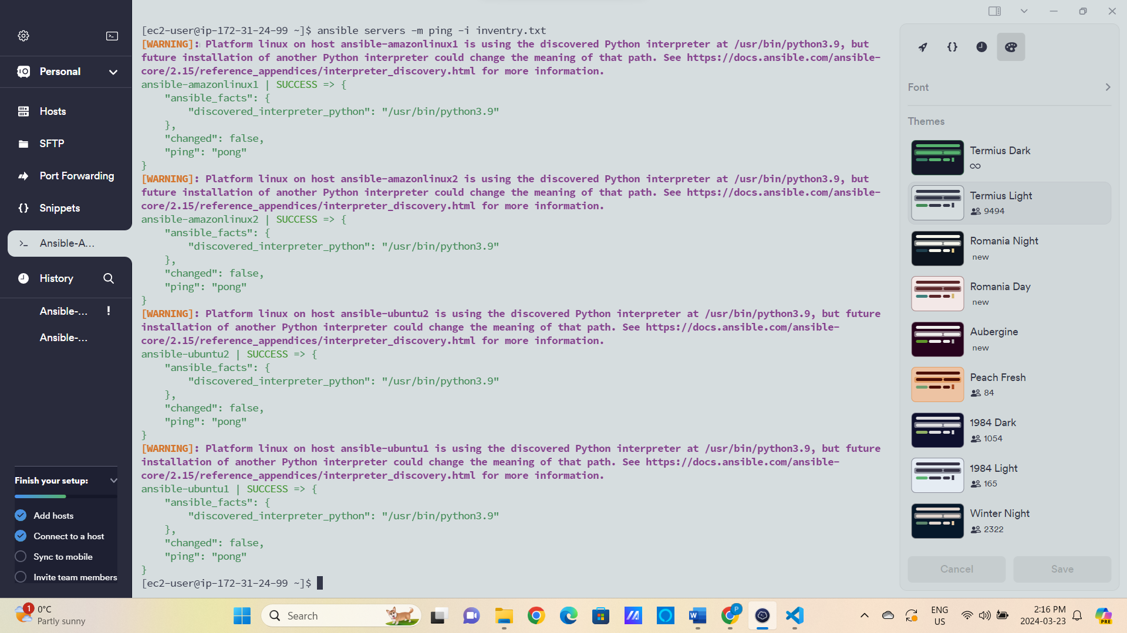

You can see we are able to connect to both the instances at once

Now I hosted the static website with help of the server

